### **Highlights**

* Utilities are compensating prosumers and passing operation costs to other consumers
* A fully decentralized peer-to-peer energy market can remove the need of a
* Mutations in SWI-SNF complex and inactivated JAK-STAT signaling enriched at relapse
* Mutational processes similar in primary and relapse; radiotherapy can damage genome

A Peer-to-Peer Energy Trading for Photo-Voltaic Prosumers

Hector K. Lopez, [hlopez5@fau.edu](mailto:hlopez5@fau.edu), Florida Atlantic Univeristy, 119 Pennock Trace Dr. Jupiter FL. 33458

Dr. Ali Zilouchian, [zilouchi@fau.edu](mailto:zilouchi@fau.edu), Florida Atlantic University

***Abstract—In this paper, the problem of implementing peer-to-peer energy markets is studied. A real-time payment algorithm is implemented with a community-manager application that helps prosumers to gain more works with the distribution service operators to manage the peer-to-peer application. Greater benefits than traditional Net Metering for prosumers without the need of decentralized communications and an isolated micro-grid configuration.***

***Keywords: Peer-to-Peer, Energy, Markets, NRG-X-Change, Utility, Renewables, Phot-Voltaic, Distribution Service Operator, Micro-grid, Blockchain, MQTT, Industrial, Smart Metering, Florida Power& Light, Net Metering, Prosumers***

**Hector K. Lopez:** Investigation, Conceptualization, Methodology, Software**,** Data curation, Writing- Original draft preparation, Visualization. **Dr. Ali Zilouchian:** Project administration, Investigation, Supervision, Validation, Writing- Reviewing and Editing.

# Introduction

The Paris Agreement of 2015 presents global ambitions to achieve a balance between anthropogenic emissions by sources and removals of sinks of greenhouse gases in the second half of this century. One solution to meet these ambitions is to reduce the emissions from fossil fuels by deploying large-scale renewable energy (RE) supply in energy systems. The increased adoption of RE technologies is driven by broader climate initiatives. By 2030 the carbon emissions are estimated to be reduced by 40% of the levels it was in 1990. These advances have been driven by innovations in resource management, government regulations and demand side management [1].



1. Increased adoption of renewable energy technologies due to regulatory push to reduce carbon emissions.

In recent years, renewable solar photo-voltaics (PV) have experienced radical cost reductions. PV accounts for the highest change in cost [2] due to improved efficiencies, material costs, economies of scale as well as public and private R&D [3] [4]. The PV cost reduction trends are expected to continue further in the future [5]. Many homes are now equipped with PV, electric vehicles (EV), batteries or other equipment [6] [7]. These homes are also connected to a smart-grid technology allowing for bi-directional flow of energy transforming these consumers into prosumers; with the ability to produce energy not just consume it [8]. With the emergence of prosumers, local Peer-to-Peer (P2P) energy transactions have been proposed as new markets allowing the direct energy trading between prosumers [9], [10]. Various trade models and clearing mechanisms for P2P energy markets have been reported [6], [11]. The benefit of a P2P energy market is to remove the intermediaries optimize the transaction of energy. Despite all the benefits it brings to the electrical grid and industry, the P2P energy trading market encounters numerous challenges. The most significant challenges include the indeterminate number of unknown peers, market-clearing mechanism, payment system, trust, and transparency [12]. Instead of creating systems that require new infrastructure and processes this paper proposes an intermediate solution by leveraging existing smart-metering hardware, ubiquitous cloud computing, and real-time demand pricing strategies.

## Related Works

Numerous studies on P2P energy trading have focused on blockchain-based P2P energy trading market designs. The blockchain serves as the principal technology to support many untrustworthy peer-to-peer financial services [13]. Furthermore, blockchain offers excellent opportunities to tackle privacy and fraud-related concerns in a P2P electrical energy market [14]. A practical implementation of a blockchain energy market was placed into commercial operation, most famously the during 2016 in Brooklyn New York [15]. Under the support of the LO3 Energy, Inc. start-up company, a citizen with PV panels on the roof of his building sold his excess electricity to his neighbor instead of feeding it to the power grid using the blockchain smart contract. By eliminating intermediaries, this scheme allowed renewable energy producers to establish P2P connections with consumers. Today, numerous studies have proposed using this technology in P2P energy trading markets at consumer and transmission levels [16] [17]. Prosumers are intended to participate actively in the market and proposed bids for energy based on forecasting of load and generation. The advantages of this market-based control concept are that it achieves close to optimal allocation, neatly balances supply and demand, and aligns preferences of self-interested prosumers [18]. However, Bidding for energy ahead of time relies heavily on predictions of future supply or demand, the inaccuracy of which translates to higher costs for both buyers and sellers. In addition, prosumers need to rely on advanced trading strategies to maximize profit (or minimize costs). Also, separate energy balancing mechanizes need to be employed to cope with real-time demand response [19]. The financial incentives of a fully decentralized blockchain for P2P energy market has yet to be proven. The lack of mainstream adoption has relegated these solutions to niche markets and micro-grid architectures [15]. A blockchain P2P energy market that leverages market-based energy trade, reduces the dependency on a Distribution System Operator (DSO). The system is capable of matching demand directly between individual agents, resulting in a more decentralized and competitive environment. But removing the DSO hampers adoption of the technology. The DSO can aid in managing enrollment, security, and privacy of the market [20]. An intermediate solution is possible that leverages the benefits of the DSO. The DSO still supplies a large portion of the typical prosumer [21].

## Contributions

This paper proposes a hardware and software solution to enable distributed communication amongst prosumer networks. The hardware solution can be implemented on the current smart metering infrastructure by the DSO, and the software solution is based on opensource technologies that could be established on ubiquitous cloud computing technologies. The paper also proposes the use of real-time pricing strategies such as “NRG-X-Change” instead of traditional market-based energy trading. The real-time pricing would consider the real-time pricing of the DSO for retail energy and allow a hybrid market between prosumer networks and the DSO that could be more financially advantageous for the DSO and prosumers compared to traditional net-metering (NEM) subsidies. The analysis of this P2P energy trading platform is done by synthesizing real-world data (EIA.gov) [22] for known service territories and the associated retail price of energy as defined by the DSO’s.

## Paper Organization

Section 2 Background, reviews the policies around net metering programs and the how its implemented in the state of florida by two of the major utilites in the state. The payments are leveraged in the case studies when analyzing the financial advantage of using a P2P real-time energy market algorithm over just being paid back using netmetering.

The paper presents a brief overview of peer-to-peer markets. In the background section the current state of a prosumer payments is outlined, covering net metering and payment tiers from a select group of utilities such as Duke Energy, and Florida Power & Light. The following section provides a breakdown of Peer-to-Peer market concepts. The A P2P market application is then designed that proposes a novel smart meter enhancement for distributed communication with low costs. A real-time payment algorithm, NRG-X-Change, is used to provide credits for prosumers and charge consumers [21]. A fully open-sourced containerized P2P python-based application is provided. Finally, in the results section data is synthesized for different sized prosumer networks from the EIA.gov website [22]. Payout for each prosumer is analyzed to determine the benefit of a photo-voltaic (PV) only based prosumer network.

# Net Metering Overview

## Advent of Net Metering

Net Energy Metering (NEM), is a compensation mechanism to encourage the adoption of residential PV systems, commonly referred to as net metering. It allowed the flow of energy to feed back into the utility grid, forcing the negative pricing of electricity to be paid back to the user [23]. The utility would have excess generation from the home that could compensate for the load of neighbors nearby. NEM encouraged consumers to spend money on PV systems without government subsidies. Prosumers with PV could reduce the need for fossil fuels, and overall electricity cost to ratepayers. The idea spread gradually in the 1980s. In 1981, the Arizona Corporation Commission approved net metering below 100 kW, the first among U.S. public utility commissions (PUC) to do so. The next year, the Massachusetts PUC followed suit. In 1983, Minnesota became the first U.S. state to enact a net metering law. More state PUCs and legislatures followed suit: the Indiana and Rhode Island PUCs in 1985, the Idaho and Texas PUCs in 1986, the Maine PUC in 1987, and the New Mexico and Oklahoma commissions in 1988 [24]. NEM has been widely implemented currently, 41 states, in addition to Washington, D.C., American Samoa, U.S. Virgin Islands, and Puerto Rico, have mandatory net metering policies in place. Some utilities have voluntarily offered NEM arrangements to customers, as well. For example, Idaho and Texas do not have mandatory NEM policies, but some utilities in those states do offer NEM [25]. Many utilities saw NEM to break the business model and often lobby against the payback at retail prices because it does not include the transmission losses and operating costs take on the utility. Despite the benefits of NEM it can also be seen as a form of “cost-shifting” or subsidy for those who invest in renewables, while others who are unable to invest in it take the cost burden [26]. In conclusion, prosumers benefit from NEM, and utilities are forced to implement NEM by Public Commissions in varying states. The retail price of electricity is not ideal as a payback price for the utilities and forces them to lobby to make it more difficult for PV adoption.

## Net Metering in Florida

This paper focuses on the “Sunshine” state in America, Florida. Unlike California the adoption of PV systems has been less aggressive in this state because of the historically low prices of electricity from utilities compared to installation costs of PV. At the end of 2019, Florida ranked fifth in the nation in total solar power generating capacity, and utility- and small-scale solar installations contributed more than one-half of the state's renewable-sourced net generation. Although Florida is one of the nation's top producers of electricity, the state does not produce enough electricity to meet its power needs. Florida is the third-largest electricity consumer in the nation, after Texas and California, and electricity demand is expected to increase in the years ahead as the state's population continues to grow [27]. The residential sector, where more than nine in ten Florida households use electricity as their primary energy source for home heating and air conditioning, consumes more than half of the electricity used in Florida. The residential DG market for Floridians is significant [27]. The utilities must compete with roof-top solar as it becomes more ubiquitous in the state. Traditional NEM policies may push utilities to become burdened with distribution overhead and have less revenue from rate payers. In Florida, the Public Service Commission requires utilities to buy back electricity from prosumers at retail prices. The NEM programs for each utility provide customers with payment for credits not used to offset energy bills by the end of the year. The main utilities in Florida are Florida Power and Light Company (FPL), Tampa Electric Company (TECO), Gulf Power, and Duke Energy [27]. FPL and the other utilities allow customers to install DG systems that generate up to a certain amount based on a tiered structure. The systems cannot be sized to produce energy exceeding 115% of the annual consumption [28].

Florida law requires that net metering customers are compensated at the retail rate [28]. Utilities break up the usage of PV systems into tiers so that they can control the amount of capacity and create safety constraints around PV installations. There are three tiers by system size; Tier 1 is 10 kW and below, Tier 2 is above 10 kW up to 100 kW, and Tier 3 is above 100 kW up to 2,000 kW. Most prosumer homes will fall within Tier 1 due to its low cost of installation and limited liability. A typical prosumer in Florida would be a Tier 1 prosumer with a system of less than 10kW of capacity. This paper leverages the prosumer constraints in Florida as guidelines to synthesize possible prosumers in the service area. Most importantly is the capable generation of a prosumer, and the retail price of energy that the prosumers excess energy would be reimbursed for. To this end the paper shall focus on the FPL utility as the DSO for the simulated prosumers. FPL’s average retail energy prices has been 12 cents/kWh for the last ten years [22] . According to a survey from the U.S. Energy Information Administration in 2018, homes in the FPL service territory had an average monthly energy usage of 1,110 kWh [22]. In conclusion, the typical prosumer in FPL’s service territory would have a generation capacity of less than 10kW, an average consumption of 1,110 kWh a month, and would be paid back about 12 cents/kWh for any excess energy generated over the course of a year.

| *Tiers* | Florida Utilities – Net Metering Requirements – 2021 | | | |
| --- | --- | --- | --- | --- |
| Utilities | System Size | App. Fee | Insurance |
| *1* | FPL | < 10kW AC | $0 | None |
| Gulf Power |
| TECO |
| Duke Energy |
| *2* | FPL | 10-100kW AC | $400 | $1M |
| Gulf Power | $400 |
| TECO | $250 |
| Duke Energy | $240 |
| *3* | FPL | 100-2,000 kW AC | $1000 | $2M |
| Gulf Power | $1000 |
| TECO | $500 |
| Duke Energy | $750 |

# Peer-to-Peer Market Overview

## P2P Energy Market Layers

The typical P2P market consists of a *physical* layer, and a *virtual* layer. The *physical* layer is the infrastructure that facilitates the generation and metering of energy for the prosumer network. A prosumer has a form of energy generation system with an inverter that converts or steps up the energy to match the homes alternating current (AC) source. The connection to most generation systems is isolated by an isolation switch for emergencies. The entering energy from the DG system immediately supplies the load of the home and any excess energy that flows in the opposite direction (into the grid) is measured by the bi-directional meter installed at the utilities distribution drop. A micro-controller with wireless connectivity, can relay the meter flow over a wireless communication backhaul to other controllers [33]. The *virtual layer* consists of the software that facilitates interactions between participants in the market. It ensures that all participants have equal access to the platform historical financial transactions. The virtual layer consists of the messaging protocol and other transmission of the messages securely to a message broker or a distributed ledger for settlement and trading transactions [29].

## P2P Energy Market Types

*Full-P2P* configurations are suitable for isolated communities where the maintenance of all the infrastructure is maintained through self-forming coalitions. In a fully decentralized market, the bilateral contracts capture both the upstream-downstream energy balance as well as forward market uncertainty [28]. To facilitate privacy and fairness systems such as blockchain based credits are used as a distributed ledger accounting. In a *Community-P2P* a community manager is chosen to take care of the privacy and fairness. The members of the community share common interests and goals even though they are not at the same location [30] may work either in a collaborative or competitive manner [9]. Participants generally trade energy through a community manager that manages exchanges outside of the community [30]. Finally, a *Hybrid-P2P* would leverage the best of both worlds and even create a hierarchal approach to stacking several Full-P2P configurations and managed at a larger scale by a *Community-P2P* commission [31].

| Types of P2P Markets | | |
| --- | --- | --- |
| Market Structure | Advantages | Challenges |
| *Full P2P* | 1) Freedom of choice and autonomy, 2) Energy use aligns with preferences, 3) Complete "democratization" | 1) Investment and maintenance with ICT infrastructure, 2) Potentially slow convergence, 3) Predicting system behavior, 4) Guarantee of safety |
| *Community-based* | 1) Enhancing community relationship, 2) Mobilizing social cooperation, 3) New services for grid operates | 1) Reaching the preferences for all member all the time, 2) Aggregating all members data 3) Unbiased sharing |
| *Hybrid P2P* | 1) ICT infrastructure and computation effort are scalable to all system, 2) Co-existent design, 3) More predictable to grid operators | 1) Coordinating internal trades in the communities with trades between high level agents. |

## Existing P2P Energy Markets

Microgrids are known as low voltage grids, which are used to supply electricity to communities that can be operated in an islanding and grid connected mode. Microgrids can have dispatchable energy resources (DERs) and gain an advantage to continuing to operate in the islanding and grid connected mode [29]. The DERs are managed by prosumers in a microgrid and can sell energy back to the grid with a benefit from the Grid. The LO3 blockchain platform has been developed as a community energy market project [34]. The members can buy and sell energy from each other with smart contracts. The Brooklyn Microgrid, project used the platform to setup the virtual layer of the market as they connected the physical layer [15]. The Brooklyn Microgrid was an apartment building in New York retrofitted with roof top solar. The residents where all consumers contributing to the generation and consumption of the microgrid. The microgrid was able to be islanded off the main power grid and service the residents in a sustainable way. It was one of the few successful pilots in north America. Unfortunately, this project has yet to create a wave of adoption across the country. In other countries efforts around energy trading platforms have yielded varying configurations and services. The German platforms such as Enerchain and Sonnen charge monthly participation fees but provide blockchain based networks that protect privacy [35]. Many other European solutions established pilots or flat fee participation on a platform [36].

# Designing A Intermediate P2P Energy Market

## Criteria

As stated in related works P2P energy markets are typically constructed using a blockchain based system to remove the need of a central authority and then use a market-based trading strategy to determine energy prices between prosumers. The goal of this intermediate P2P market design is to leverage the existing utilities infrastructure, and a real-time payment of energy based on local demand. The benefit of having this design is that it can be implemented much easier and possibly provide more financial benefit to prosumers than the existing and widely used NEM.

| Process Comparison of NEM vs. Proposed P2P Energy Market | | |
| --- | --- | --- |
| Constraints | Net Metering – Process | P2P Market – Process |
| *Participants* | *Florida Residential Prosumers* | *Florida Residential Prosumers* |
| *Technology* | *PV, Energy Storage* | *PV* |
| *Capacity* | Tier 1 : *PV capacity <10kW* | Tier 1 : *PV capacity <10kW* |
| *Payment Scheme* | Maximum payment assigned monthly by Utility and paid to all excess energy equally regardless of demand from network. | Fluctuates based on demand of others on network, not more than utilities maximum payment amount for that month. |
| *Metering Infrastructure* | Smart Meter (typical installation) | Smart Meter with an additional P2P Meter to send data to P2P Market message broker |
| *Centralization* | Managed fully by the DSO | Hybrid, Physical systems managed by DSO, transactions and ledger managed by P2P Market message broker application |
| *Physical Security* | Physically secured by DSO and regulations around utility equipment | P2P meter form factor sits behind utilities Smart Meter and leverages same physical security from the DSO |
| *Cyber Security* | Managed by the DSO through utility customer service | Managed by the P2P Market Community Manager |
| *Enrollment* | Managed by the DSO | Managed by the P2P Market Community Manager |
| *Communications* | Smart Meter wireless backhaul LTE | P2P Meter wireless backhaul LTE-M |
| *Operating Costs* | Integrated in cost of electricity | Monthly subscriptions for cloud services and LTE communications |
| *Installation* | PV, Disconnect Switch | PV, Disconnect Switch , P2P Meter , Cloud-based P2P Market Application |

## How it Works

For P2P energy markets a blockchain based system is typically used to aid in managing enrollment, security, and privacy of the market [20]. The blockchain infrastructure requires added cost and complexity to establish a distributed ledger across a scalable network of prosumers. The DSO and a Community Manager could handle the physical layer and the virtual layer respectively.

Florida has a regulated electricity market. A P2P market that can provide additional revenue outside of the NEM subsidies would require a utility to have prosumers opt into the program. Prosumers would forego the payment from NEM for the payment determined by the P2P Market algorithms. Prosumers would gain the ability to sell excess energy at the minimum retail price of energy and more depending on the demand from neighboring consumers. The consumers who are part of the network could have the retail rate of electricity reduced by when there is enough excess energy. The consumers would be able to have cheaper electricity rates while generation is available from prosumers.

## Prosumer Setup

In Fig. 2 a typical prosumer is shown to produce energy, P1, by conditioning it and sending it to the grid, M1 and consuming C1 energy from the grid when production doesn’t fully cover the load of the home as seen

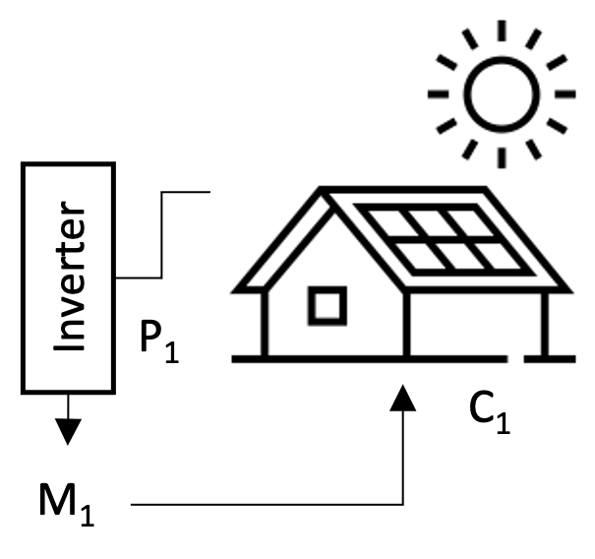

1. A typical prosumer configuration with solar PV installation and inverter.

An AMI meter is connected to the homes load and measured by the utility at M1. An inverter is and emergency isolation switch is connected to the renewable energy sources behind the meter. The excess energy flow into the grid when it is greater than the load of the home. The utility grade meter then measures the reverse flow as net energy of the prosumer. A typical connection to measure flow independently requires expensive and time-consuming modifications to the wiring behind the meter. A novel proposal is to utilize the existing AMI form factor and implement a plug-n-play solution with a secondary unregulated meter in-between the AMI meter and the meter-can housing.

1. A typical AMI meter with a proposed P2P meter interface that would interface with pass through connectors. The P2P meter contains LTE and current sensing capabilities.

By first proposing a typical prosumer and defining a prosumer network model a P2P energy market can be proposed that can facilitate energy transactions between the prosumers in a network of any number of prosumers. This paper shall focus on PV only based prosumer generation sources. Future works should consider PV and energy storage capabilities for each prosumer.

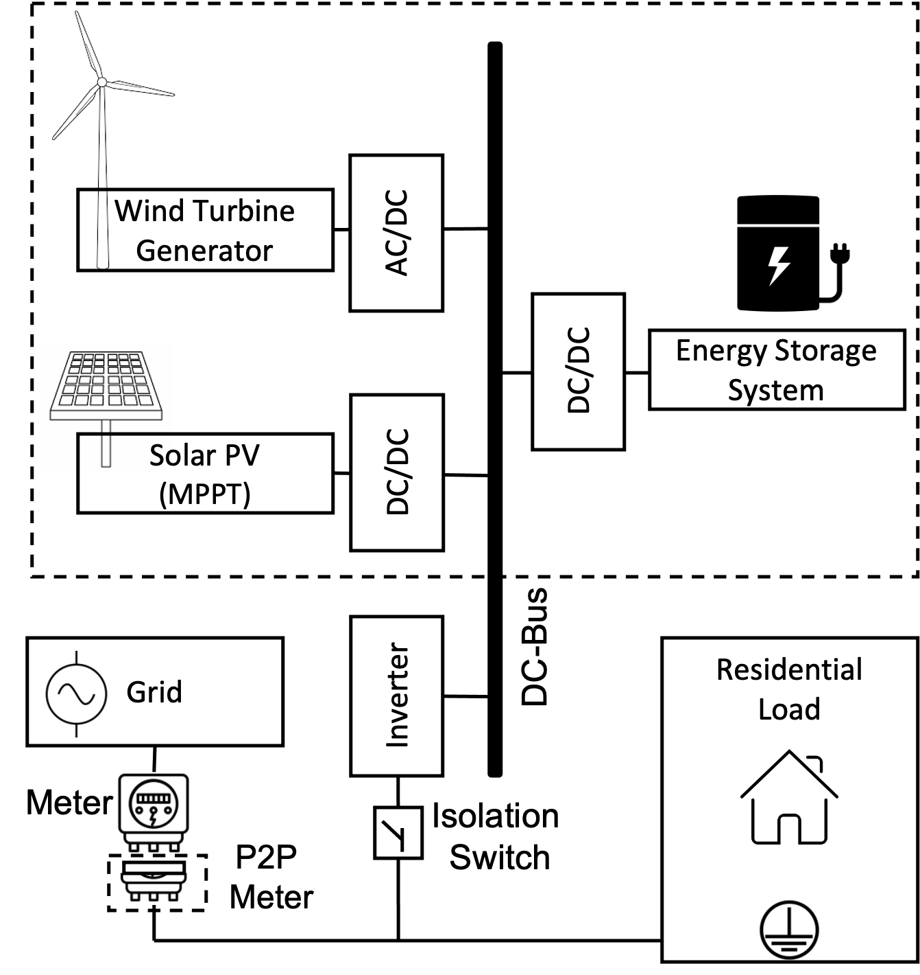

1. A typical residence with renewable power sources is connected to the sources through an inverter that converts DC to AC . The generation simulatneously feeds the load and the grid at a point of interconnection netting out the final usage of the home as positive or negative flow as measured by an electrical meter.

## Prosumer Network Setup

The network of prosumers and consumers could be isolated behind a substation, allowing for micro-grid isolation. The need for micro-grid isolation is optional because the network can still act as a virtual ledger managed as an unregulated service by the utility during normal service operation.

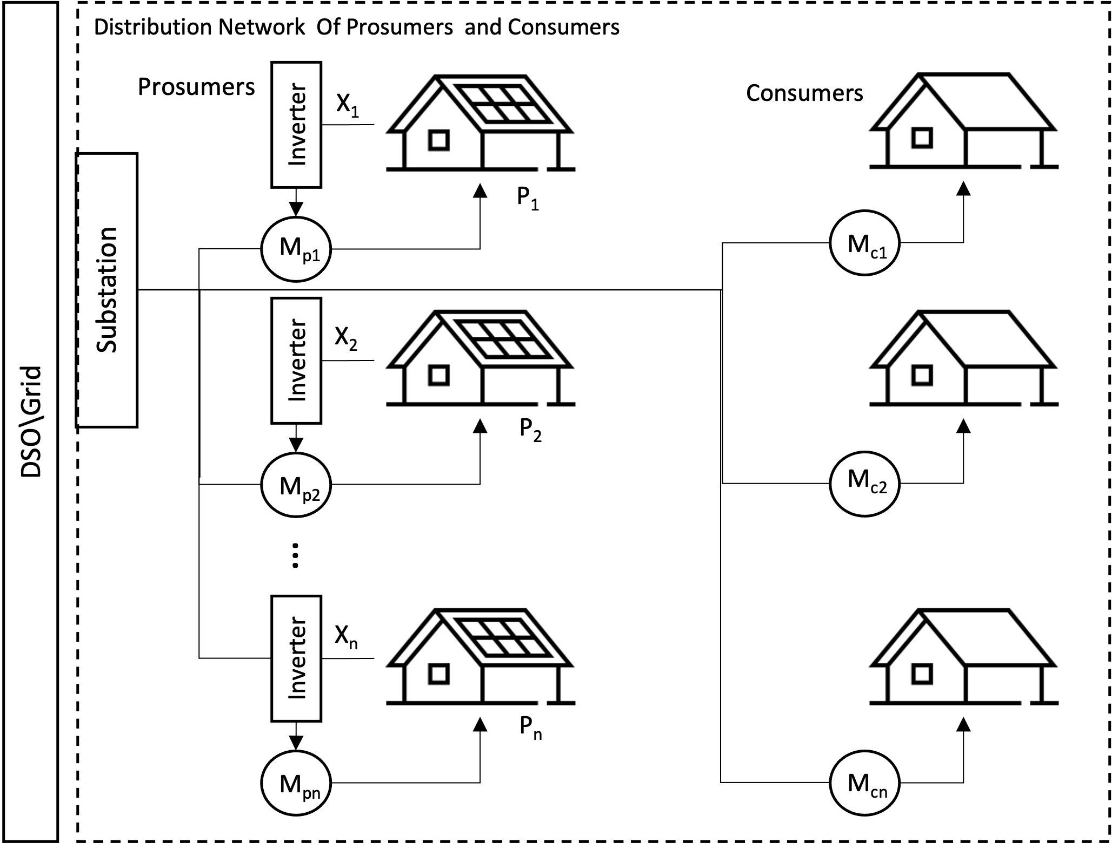

1. Network of Prosumers and Consumers feeding and recieving directly from a substation managed by a Distribution Service Operator. *M* number of participants on the network ranging from 1 to *n* number of prosumers, *p* and consumers, *c*.

## Prosumer PV Modeling

PV technology is simple in structure, stable in performance and does not produce any pollutants in the process of power generation; therefore, it is very suitable as a renewable power source in microgrids. It converts solar irradiation to electric, and the photoelectric effect electric current is:

Equation .

Where q is the electron charge, $V$ is the cell voltage, and $R_{s}$ and $R_{sh}$ are resistance connected in series and shunt resistance, respectively. $K$, $T$ and n are Boltzmann constant, operation temperature, and ideality factor of diode, respectively. Light-generated electric current is shown as $I_{ph}$ and saturation electric current is shown as $I_{s}$.

Equation .

Equation .

Where , , and $T_{ref}$ are solar irradiation, solar irradiation at standard condition, and reference temperature, respectively. The reverse saturation electric current, $I_{rs}$ is expressed as:

Equation .

Where Voc and Ki are open circuit voltage and short circuit current coefficient, respectively. The power of the PV model is obtained by the multiplied model current and voltage, and expressed as:

Equation .

The consideration of losses in converting the PV energy to AC by the inverter is not considered as well as other minor losses due to system constraints. The ideal generation of the PV system can be modeled to understand how a typical prosumer would respond to measured irradiance in a location over time. If a series of prosumers interacted with consumers in a network the prosumers would be able to provide excess energy at times that the consumers would need it. The prosumer network is represented by the set of prosumers, $P\left(n\right)$ where N is the total number of prosumers in the network.

Equation .

In a P2P market the prosumers excess energy is paid to the prosumer at a market price. The excess energy is referred to as net energy and it is the difference between the prosumer’s load and the prosumer’s generation. An individual prosumers net energy at some time $x(τ)$, is calculated by taking the difference between load and generation of that prosumer and clamping the value to be above 0.

Equation .

## Prosumer Payments

To pay a prosumer for the net energy, the net energy must be multiplied at some time dependent retail price, $q(τ)$. The retail price is dependent on time because it is a value that changes based on demand and costs to distribute energy. The retail price would also need to be in some monetary denomination per kWh.

Equation .

An individual prosumers payment can also be dependent on the demand so the retail price, $q(τ)$. Can be expanded to include the terms for the total generation of the network, $t_{p}$ and the total consumption of the network, $t_{c}$.

Equation .

Equation .

Since excess energy is not valuable when there isn’t anyone to consume it, payment to the prosumer should be regulated so that the payment is based on the group contribution of energy so that it is balanced with the demand. To balance the supply and demand amongst a network of prosumers we want to compensate generation and load on the network at the correct times as proposed by the NRG-X-change mechanism [37]. A prosumers payment function is a modification of the maximum retail price at that time awarded for the energy. The individual’s contribution to in comparison to the need of that contribution is considered. The final price for the energy is then attributed to the prosumer at that time.

Equation .

Where the $q_{max}$, is the maximum payment for the prosumer’s energy and where $a$, is a constant that is used to tweak the distribution of the payment. A recursive function is used to home in on what an accurate constant should be for the payment function given the scale of the network. As the disparity between the single prosumer and total load and generation could be the scale factor should be adjusted. Implementing a sensitivity analysis of the scaling factor $a$, with respect to the net energy squared reveals that the scaling factor should be greater than or equal to the net energy squared, but the small enough to not become undefined.

A consumer payment function is considered in a similar way. The prosumers or consumers that require to draw energy from the network would be charged according to the overall demand. The price of energy increased based on the demand forcing the behavior to change for consumers who do not wish to pay for higher prices at the demanded time.

Equation .

Where is the maximum cost of energy delivered by the DSO when the energy supply by the prosumers is low. When the production matches consumption the substation will charge $\frac{r_{max}}{t_{c}}$ per kWh.

## Market Design

The NRG-X-change protocol proposes an interchange of energy transactions leveraging a DSO as an intermediary and broker for the market. (NRG,) The advantage of this design is that it creates more privacy for the participants of the service, and it gives control to the DSO to implement incentives for ancillary services. Approaches that leverage blockchain technology help to increase security and privacy for each person on the network. The costly implementation of blockchain however continues to be an area of research. The transactional speeds slow down as the network grows and the complexity of implementing a viable blockchain network requires expertise by the prosumers that can be more costly than the service. To keep costs low hybrid P2P architecture is proposed. Prosumers would have a community manager initiate a software application under and organizational account with a reliable cloud hosting vendor. The market transactions would occur entirely on the market application. The metered energy flow would be sent to the application and a centralized ledger would be kept of the payment and cost for the energy on the network. Payment for each prosumer is calculated in real-time by the broker using the NRG-X-change algorithm and recorded so that the settlement is provided to the prosumer and consumers that participate in the network.

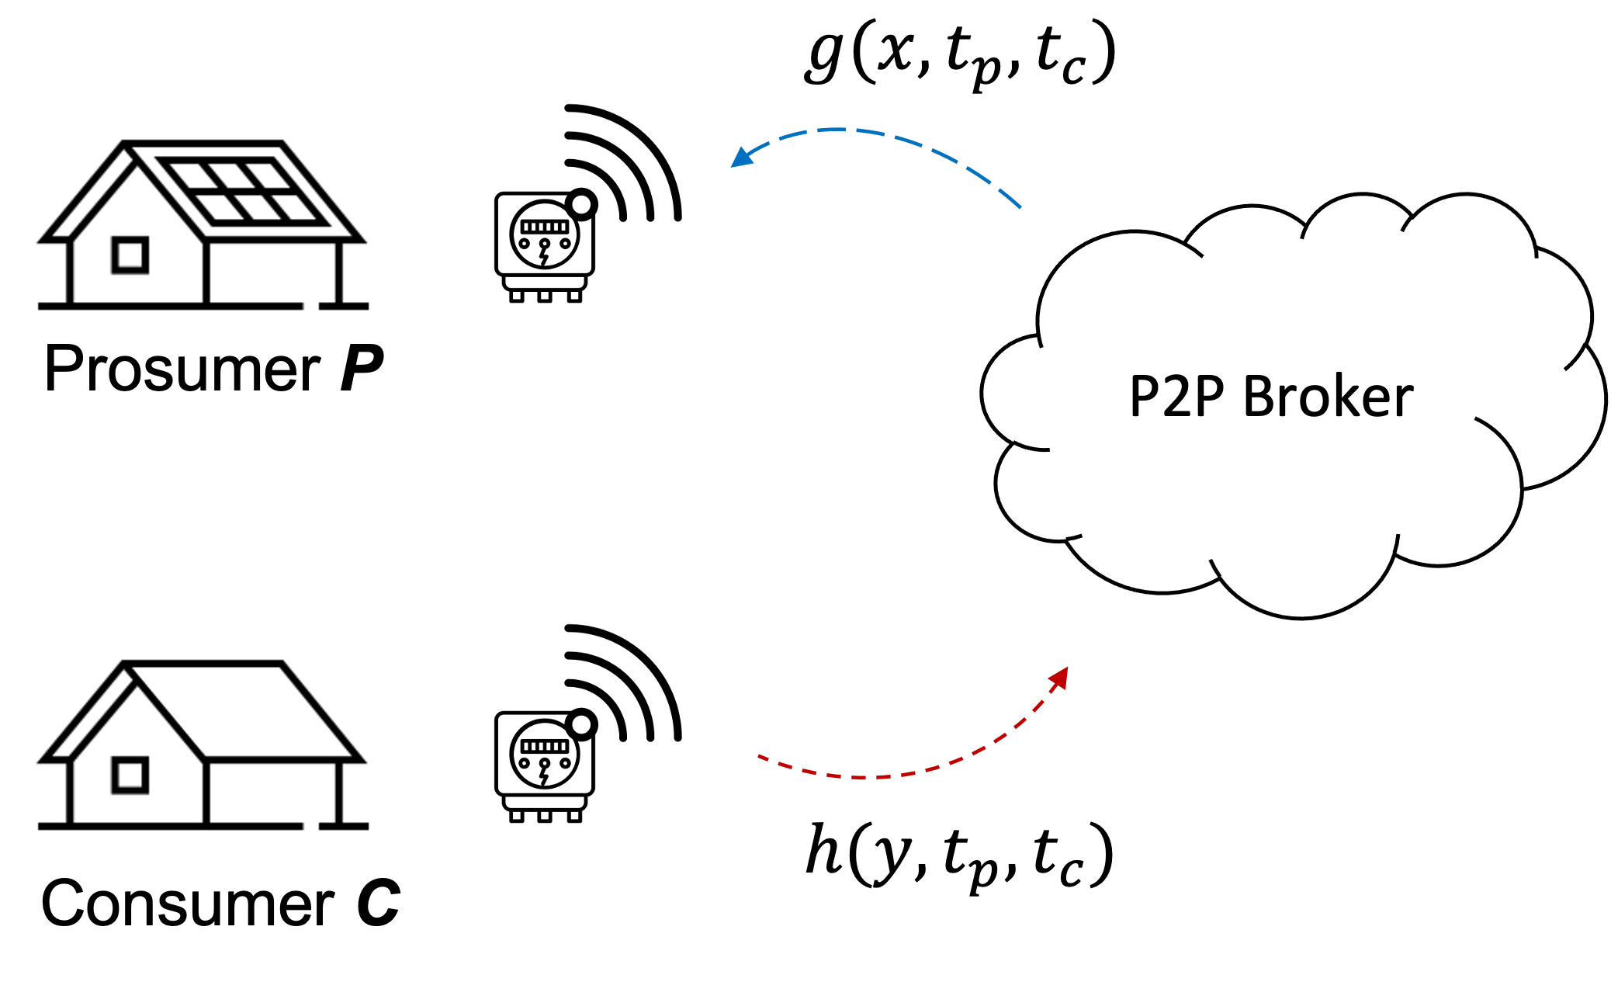

1. Enrolled prosumers and consumers send transaction information that is then paid using the revenue , g(.) and cost , h(.) algorithms.

# Implementation

A proposed implementation of the communications of a P2P market is to include an Internet of Things (IoT)capable meter with access to a wireless cellular connection. The meter would measure the power in kilowatts consumed or produced at the point of interconnection with the grid. The meter would then send messages to the P2P broker. The messages are sent over the proposed P2P meter using a wireless backhaul such as LTE-M or LTE. Each P2P meter would send messages over an OASIS standard messaging protocol for the IoT called MQTT. It is designed as an extremely lightweight publish/subscribe messaging transport that is ideal for connecting remote devices with a small code footprint and minimal network bandwidth [38].The messages contain simple record structure to identify the Customer Id, and the kilowatts associated with the meter, finally a timestamp would be sent along with the message to accurately track the flow of energy. The messages arrive at the publicly available MQTT broker endpoint. The messages are then sorted by timestamp into a stream and processed to determine the payment or billing amount for each customer at every associated timestamp. At any given time, the balance of the customers would be available on a management portal.

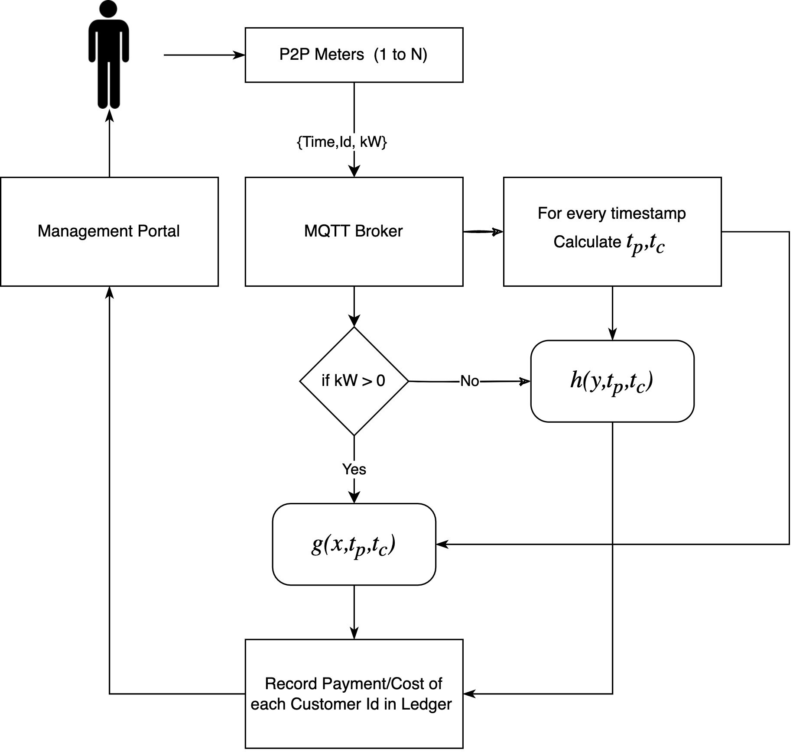

1. Simplified flow chart of P2P application leveraging NRG-X-Change algorithm for prosumer payment and billing.

## Message Structure

The MQTT messages are encoded as binary messages. The P2P meter would send the values to the broker as an encoded string with any series of information within it. To make the simulation simple the use of JSON (Java Script Object Notation) is used to define a message structure. An additional feature that is proposed that is not normal for IoT operations is the use of a “quality” code value. The quality code is used in industrial protocols to define low level health status of devices. These quality codes are well defined in Industrial Control System protocols such as OPC, OPCUA, and DNP3. The quality of a given OPC tag is used to represent the validity of the tag's value (in other words, whether a client can trust the data). OPC quality is divided into three main categories: Good (generally indicates the data is valid), Bad (generally indicates the data is not valid), or Uncertain (generally indicates the data is speculative in some manner). Each category is further divided into sub-categories; the exact criteria for using a particular sub-category may vary depending on the end protocol and vendor. The value for the timestamp should be chosen to be a point in time counter type time designation to avoid issues with time zones such as the Unix time (also known as Epoch time, Posix time) that is widely used in operating systems and file formats. Finally, the value for the energy is chosen to be a positive or negative value defined as a floating-point value of kilowatt.

{

'time': 1637984408,

'qos': 0,

'id': 1,

'kW': 0.12,

}

1. JSON formatted P2P meter message structure with sample values for each field, time is the timestamp of the message as unix time, qos is the quality code, id is the customer identifier, and the energy is defined as kW.

## Message Processing

The records arrive on the message broker in asynchronous order. The MQTT protocol allows for the messages to arrive at a given ‘topic’ that any MQTT client can subscribe too and listen to messages as they arrive on the topic. The published messages are available for the subscribed client. The client subscription requires the defined broker endpoint, the port that is typically 1883, and a name for the connecting client. An example of the mosquito MQTT application is shown to indicate how a user can test the submission of the message through a command line.

mosquitto_pub -t INFO -m '{"time": 1637984408, "qos": 0, "id": 2, "kW": 0.173}'

1. Example of a paho mosquitto MQTT terminal console command to publish a test message to the INFO topic on a local broker.

## P2P Broker Awaiting Messages

A more exhaustive script is if leverages the paho MQTT Python library to simulate a subscription to the broker at the given topic. The main method handles the long running task and loops forever expecting messages to arrive on the broker from P2P meters. The override function ‘on_connect’ determines what happens when a successful connection is established.

import threading

import paho.mqtt.client as mqtt

import json

import pandas as pd

import time

mqttBroker = "localhost"

mqttPort = 1883 *# port for mosquitto broker*

client = mqtt.Client("p2p-broker") *# new instance*

msg_dict = [] # create a list to store the messages

def main():

*# Define callback function for success connection*

client.on_connect = on_connect

*# Define callback function for receipt of a message*

client.on_message = on_message

*# Connect to the broker*

client.connect(mqttBroker, mqttPort, 60)

*# Start networking daemon*

client.loop_forever()

def on_connect(client, userdata, flags, rc):

print("Connected with result code {0}".format(str(rc)))

client.subscribe("INFO")

1. Python script showing the main entry point for an MQTT client connecting and subscribing to the P2P broker (hosted locally).

The client also overrides the “on_message” method so that the processing of the incoming messages is performed. The method converts the binary string into a JSON formatted object and stores it as a record in a thread safe list. A separate thread is invoked that loops every few seconds and processes the messages into the total production and total consumption grouped by the time interval. The methods also remove any duplicate messages that arrive on the broker based on timestamp and customer Id. This forces the messages to be unique. Note, that the synchronization of messages from each meter is not considered. The assumption is that all messages will arrive at a synchronized clock rate, i.e. once per second. If the messages are out of sync the aggregation of energy supplied or consumed may not be as accurate. Aggregating towards a common time window or even creating back casting methods to smooth out errors would result in more robust energy attribution across the network.

def on_message(client, userdata, msg):

# convert msg to json

data = json.loads(msg.payload)

# check if data is in dict

if not any(msg['time'] == data['time'] and

msg['id'] == data['id'] for msg in msg_dict):

# store data in a dictionary

msg_dict.append(data)

def thread_process_msgs(id):

while True:

try:

df = pd.DataFrame.from_records(msg_dict)

tp = df[df['kW'] > 0].

groupby(['time']).sum()

tc = df[df['kW'] < 0].

groupby(['time']).sum()

# itterate through values of tp

for index, row in tp.iterrows():

# update df with tp at time index

df.loc[df['time'] == index, 'tp'] = row['kW']

for index, row in tc.iterrows():

# update df with tc at time index

df.loc[df['time'] == index, 'tc'] = row['kW']

time.sleep(2)

df = calculate_nrg(df)

except Exception as e:

print(e)

1. Python methods demonstrating a threaded process that reads messages on a list and aggregates the total production and consumption of each group at the given time interval the messages where sent.

## P2P Broker Calclating NRG-X-Change

The payment and billing functions as described by the NRG-X-Change [21] algorithms are implemented on a central broker then provided to consumers as the final payment or bill that should be issued. This method is simpler than creating a blockchain based network and is a lower cost and lower complexity implementation at the sake of decentralization. The payment calculation is done on the P2P broker and is done at a configured rate. The configuration for the scaling factor and the max price of produced and consumed energy must be set by the community manager of the P2P network. In this example the defaults are set in the script based on historical max and min pricing from the synthesized dataset.

*# NRGXChange Payment g(.) Function*

# price : the maximum price for energy produced

# tp : the total production of the network

# tc : the total consumption of the network

# a : scaling function

# n : number of particpants on the network

def g(price, X, tp, tc, a, n):

q = price

try:

pay = (pow(X, n)*q)/math.exp(pow((tp-tc), 2)/a)

except OverflowError:

pay = float('inf')

return pay

*# NRGXChange Charge h(.) Function*

# price : the maximum price for energy consumed

# tp : the total production of the network

# tc : the total consumption of the network

def h(price, Y, tp, tc):

r = (0.01*price)

try:

cost = (Y*r*tc)/(tc+tp)

except OverflowError:

cost = float('inf')

return cost

1. Python scripted payment and cost functions for prosumers and consumers conversion of *X*,produced energy and *Y*, consumed energy.

## P2P Broker Management and Visualization

Cloud services provide scalable, reliable, robust solutions that can be secured for privacy. A containerized approach to the application would allow the application to be hosted on any cloud vendor. The P2P application would manage the enrollment, pricing, and settlement of the energy for each prosumer. By allowing the application to be configured the community manager can adjust max retail electricity costs and payments from the DSO. The architecture utilizes MQTT to facilitate a publish/subscribe style of communication. The transaction of the system is brokered and recorded through various microservices. The design can be scaled and distributed across agents. Leveraging the scalability of the cloud to support a growing P2P network. The architecture can be described as a monitoring stack and a management stack with a transactional layer.

### Monitoring Stack:

Comprised of opensource software that reads in messages through Filebeat, an agent that can receive MQTT messages from a MQTT broker on the transactional layer and relay it to Elastic, an opensource unstructured database. The final component is Kibana, a dashboard visualization application that could provide event level details of each event for monitoring.

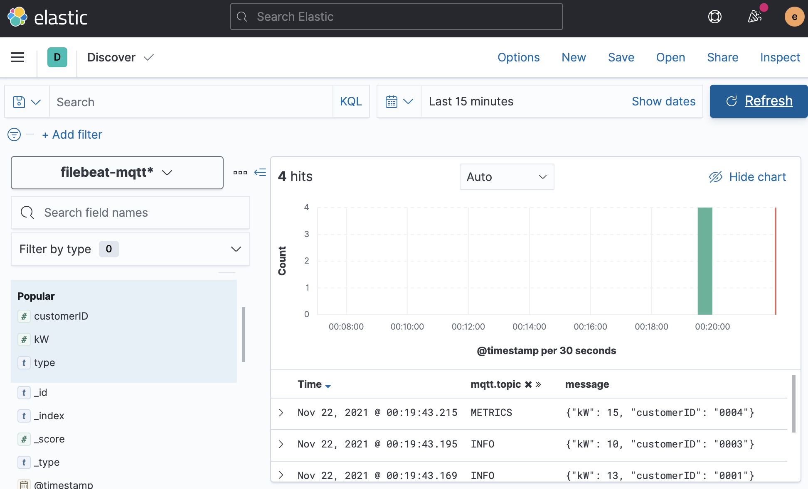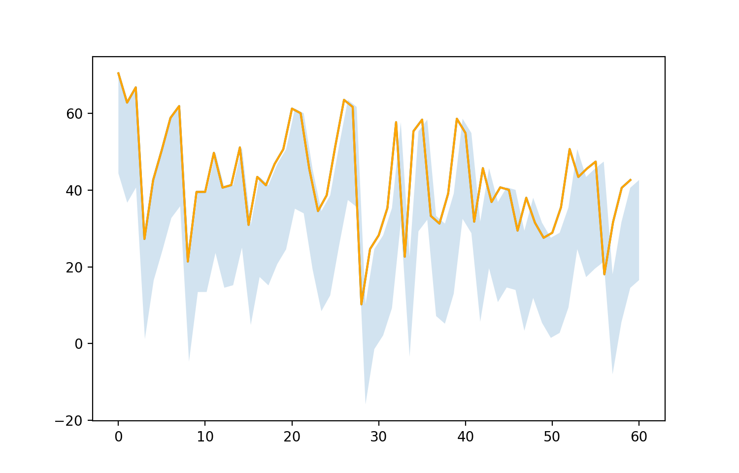

1. Elastic Dashboard and transactions showing the particpants submit customer IDs and the corresponding kWh reading to the broker.

The management stack is used to implement management roles such as enrollment, configurations, and adjustment. It can also host a public website as a portal for participants to look at what the balance is and adjust account settings. This layer relays all changes to the MQTT broker in an asynchronous manner to the monitoring stack. The most important component is the “Broker”, a custom agent that performs the energy balancing and ancillary energy management services between all the participants of the network.

### Transactional layer:

A layer that facilitates communications between participants and the management and monitoring stacks. It is made of MQTT broker that is opensource by Mosquitto.org, the exchange information can be asynchronous and passed rapidly using “publish” and “subscribe” transactional messages between the participants and the stacks. This methodology allows for distributed communications.

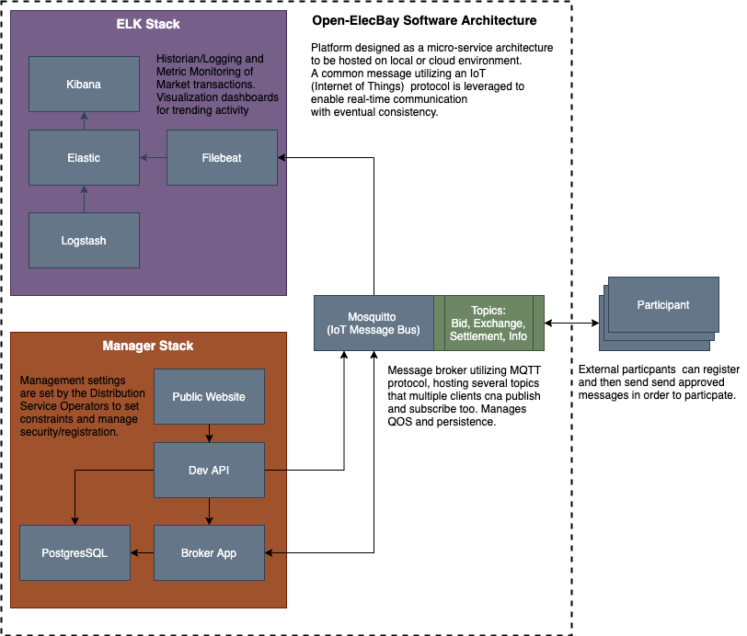

1. Microservice based software architecture diagram for P2P market broker application with management console.

# Simulation Results

To simulate the results of the system data was synthesized from annual consumption trends and the regulatory constraints of the geographical region of Florida. The assumptions around the size and limits to PV systems were considered based on sources from EIA.gov [22] and NREL (National Research Energy Labs). The synthesized data was then used to generate results of prosumers payback for a network of N=3 prosumers and for a network of N=100 prosumers. The prosumers would consume a load first and then provide any excess generation. The variations in generation and consumption are modeled with a statistic variance to cover variations in home sizes, location, losses, and other performance considerations. Future works would consider the integration of energy storage alongside the PV generation that could offset generation capacity allowing for greater revenue opportunities.

## Synthesizing Data for Florida Prosumers

The data used in the simulation is provided by the U.S. Energy Information Administration (EIA) [22] through an application programmable interface (API). The dataset is filtered for the Florida Power and Light service territory. The two datasets requested are for load demand and solar generation. The prosumers load demand must be derived statistically since an individual’s load is not made available through public datasets. The average use of a single prosumer can be inferred at a monthly time range but not on a daily or hourly time. The average monthly estimate for a prosumer in the FPL territory; 1,110 kWh/month. The hourly and monthly load demand is publicly available data, but it is on an aggregate. To be able to use this data normalize the aggregate usage over a time window then multiply the estimated mean usage by each of the normalized samples over the time window. The result would be a load demand curve that estimates a typical prosumer load demand about the average load. The 1100kWh per month was divided by 730 hours in a month to arrive at a 1.5kW load at each hourly sample. The normalized curve was mapped against the load with two standard deviations as an error.

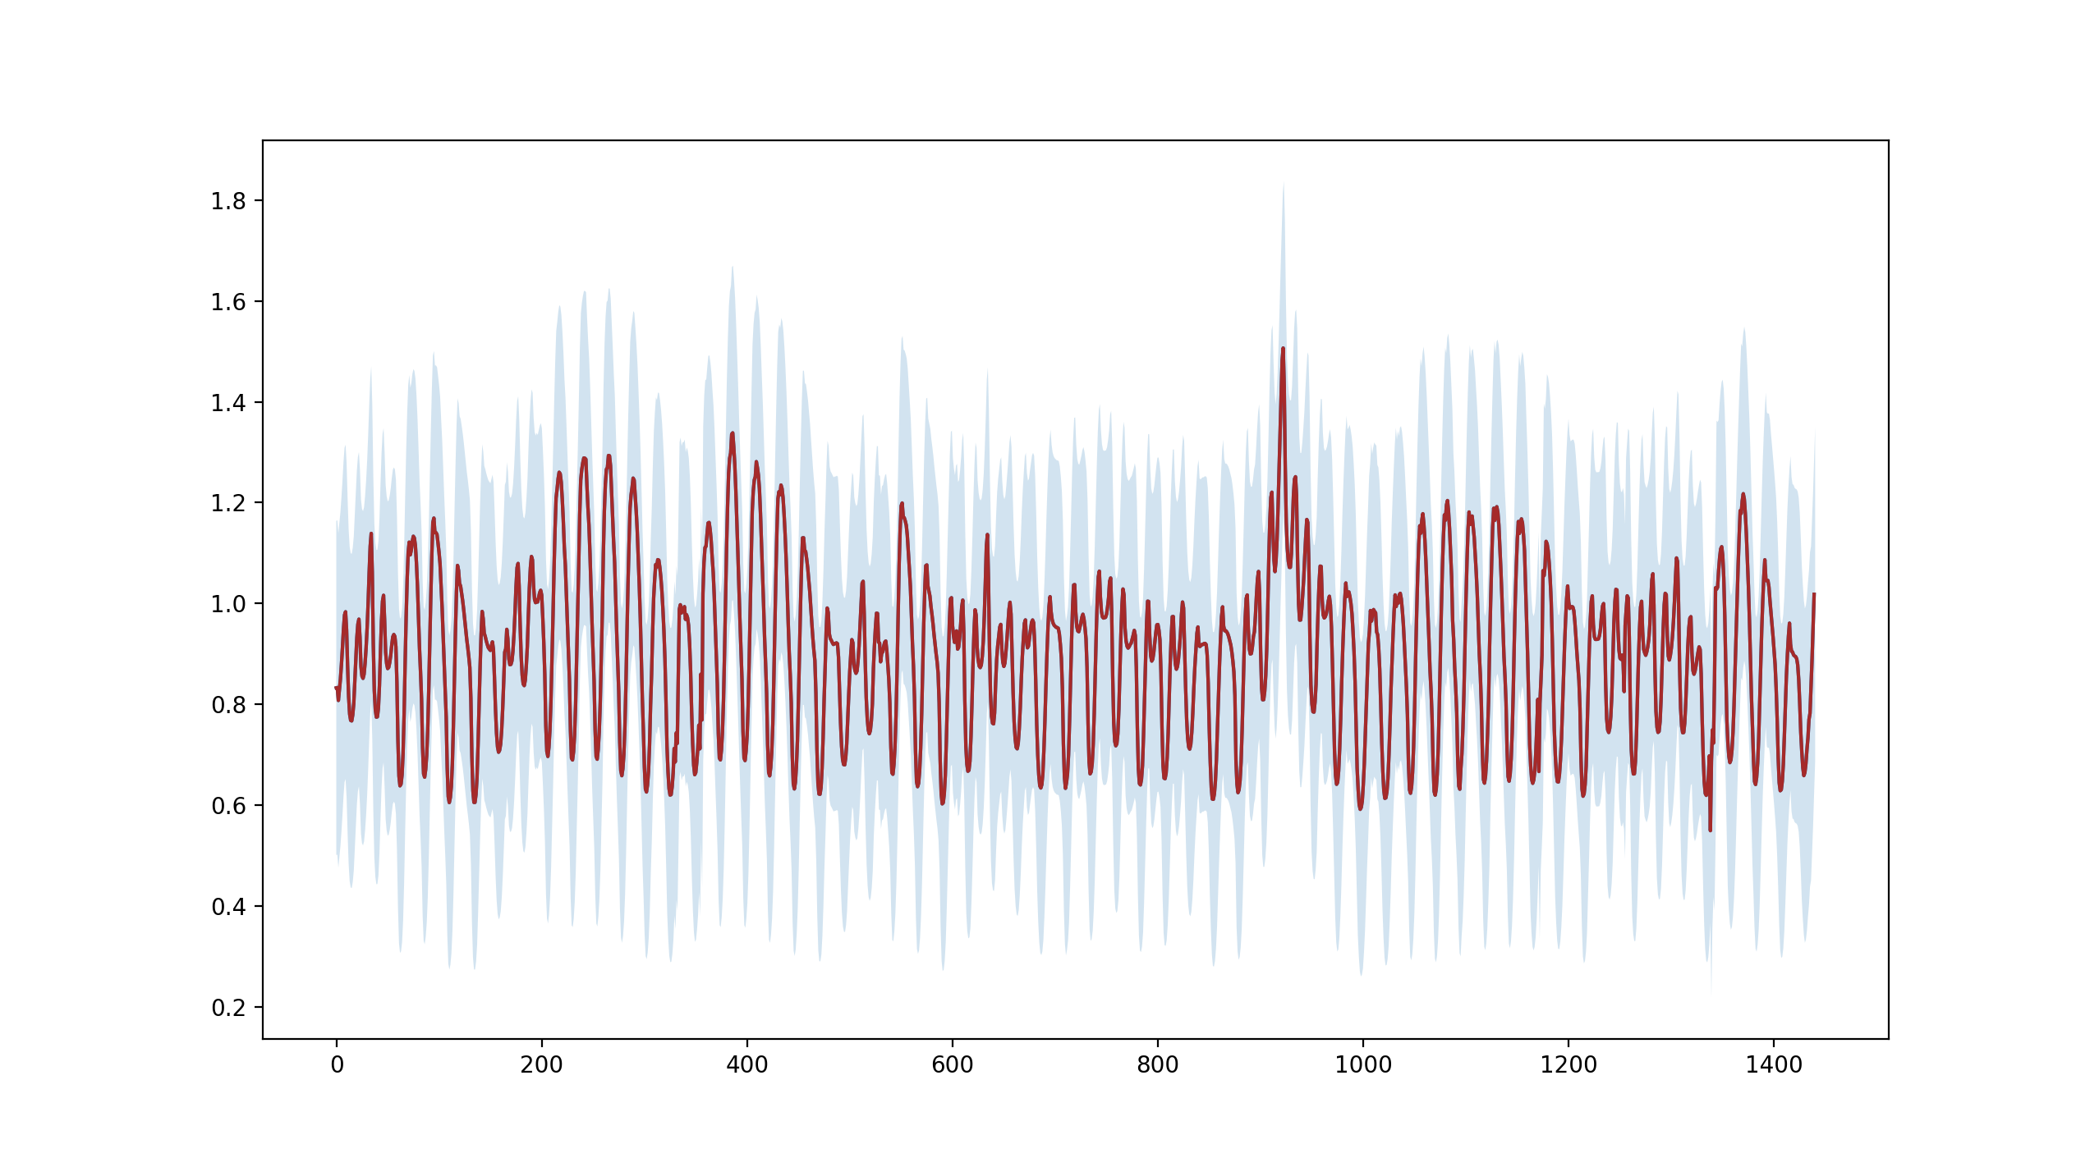

1. Hourly load demand (kWh) about an average prosumers load of (1100kWh/730h) between Jan. 2020 and Feb. 2020 with an error band of 2 standard deviations.

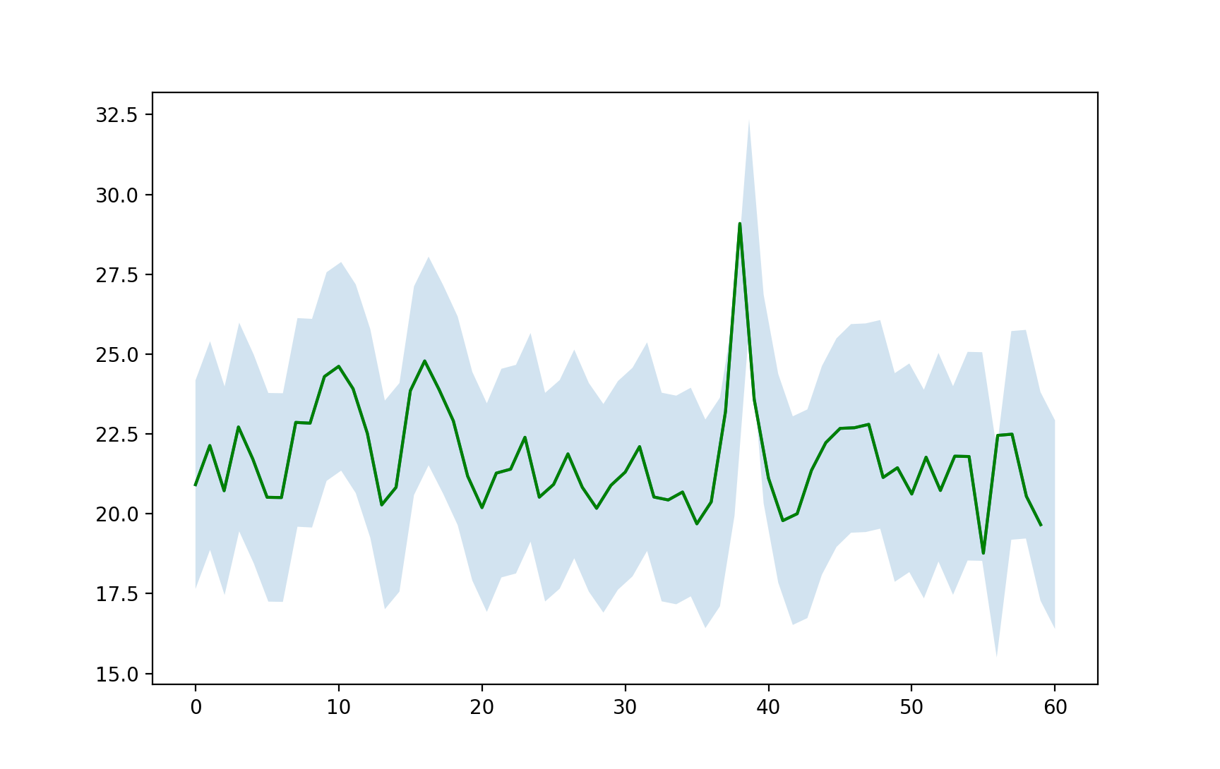

1. Daily load demand of a typical consumer that draws an average of 1100kWh a month correlated to the normalized curve of overall demand between January 2020 and end of February 2020.

The approximation provides a starting point to model a prosumers daily consumption. The prosumers variance of consumption is considered as two standard deviations from the mean but can be adjusted in future research. The actual load demand of individual users can be utilized instead of this approximation into the model for better results. In this research we will assume PV is utilized by the prosumers, but this can be adjusted to be different types of generation with different driving renewable energy curves. The total solar generation of the FPL territory is an indicator of the potential capacity of a prosumers much smaller generation. The assumption is that the total correlation of solar generation on aggregate is proportional to the solar generation at the prosumer level.



1. Daily generation of a Tier1 solar system installed on a a typical prosumer as a proportional correlation to the normalized curve of FPL’s overall generation from solar start of January to end of February, 2020.

## Prosumer Network Revenue

The analysis shows the positive and negative transactions for the energy generated by each of the prosumers. The prosumer revenue for id=3 generated the most revenue over the course of the year. The analysis shows that with only PV the network is dependent on variance in load and generation performance. At larger networks the revenue per prosumer tends to decrease. The variance in performance for each prosumer works against the revenue gains for each prosumer across the network.

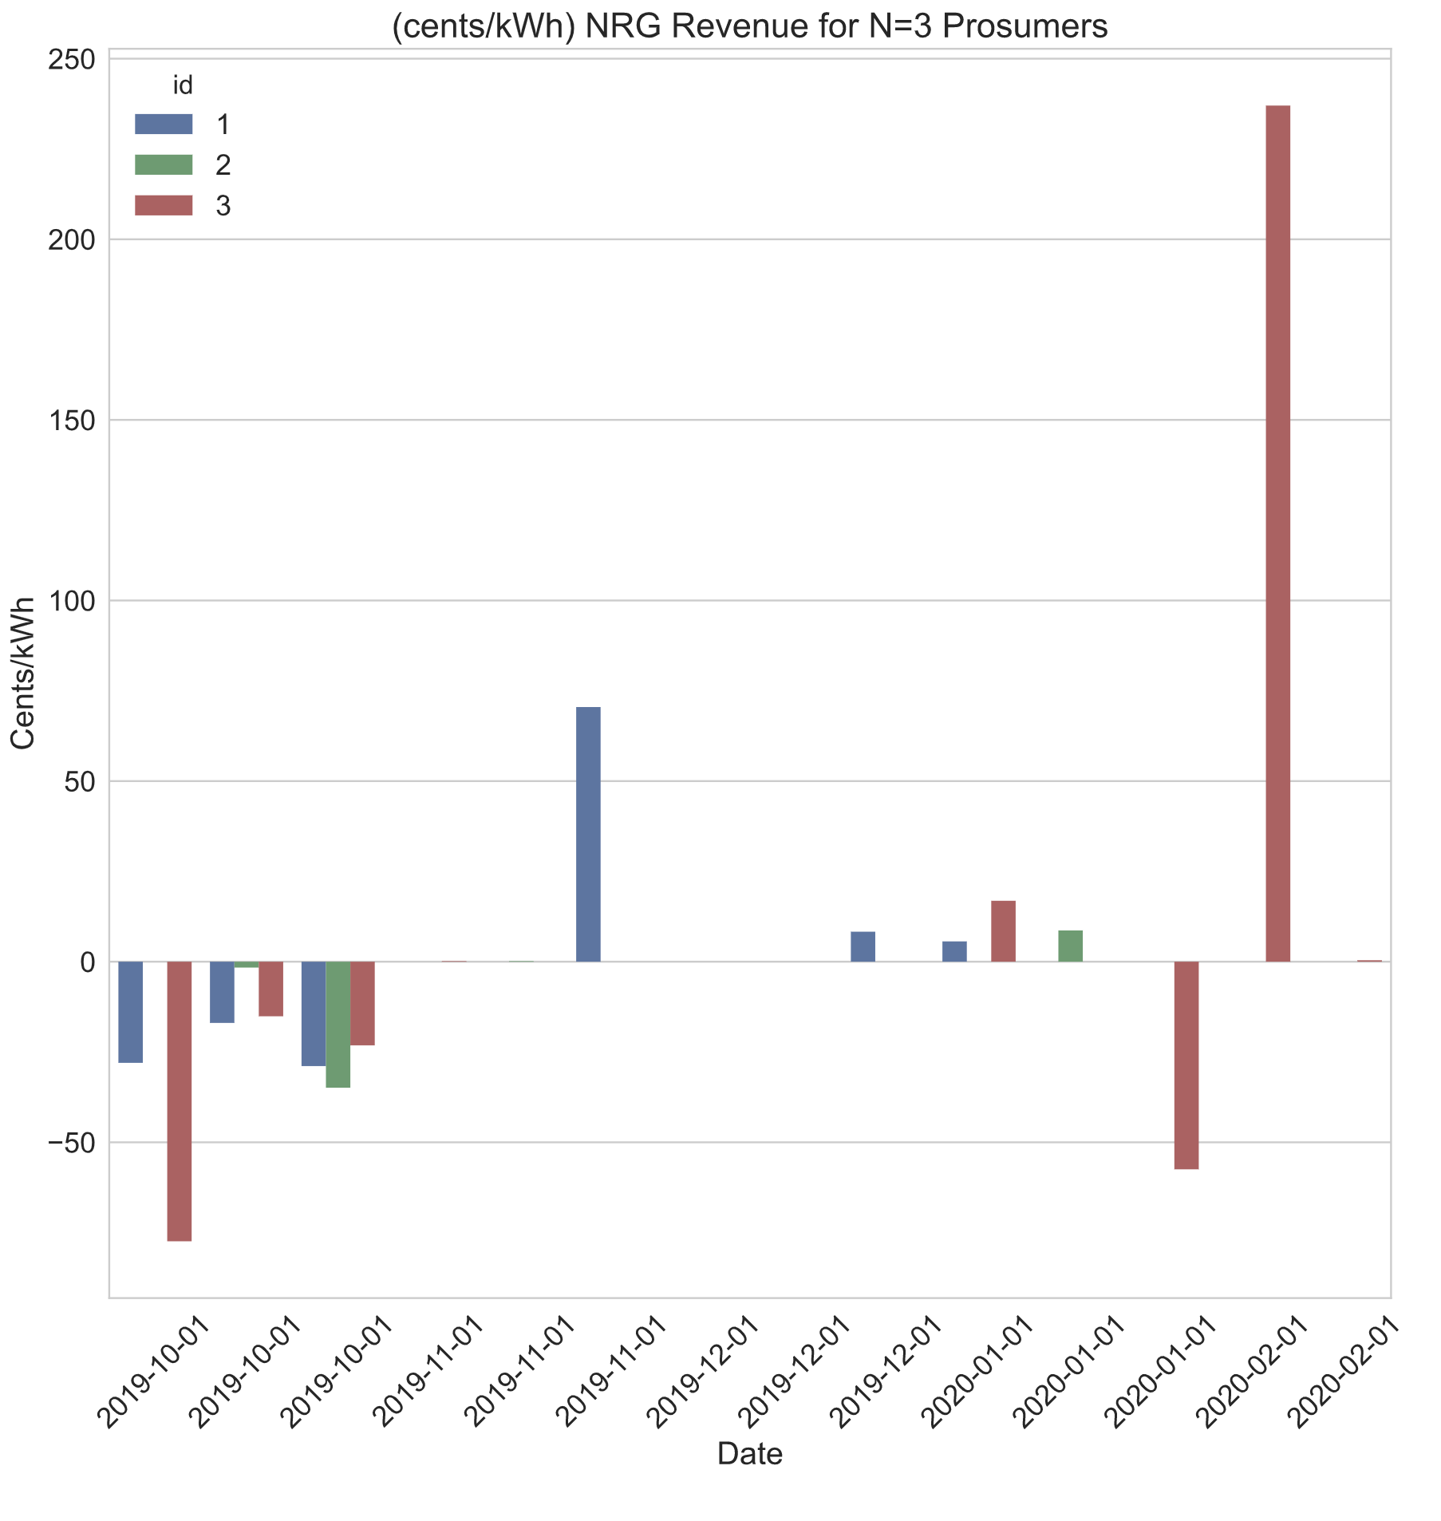

1. Hypothetical generation of Prosumers in a network of N=3 using NRG-X-Change mechanisim for the FPL synthesized data; start of January to end of February, 2020.

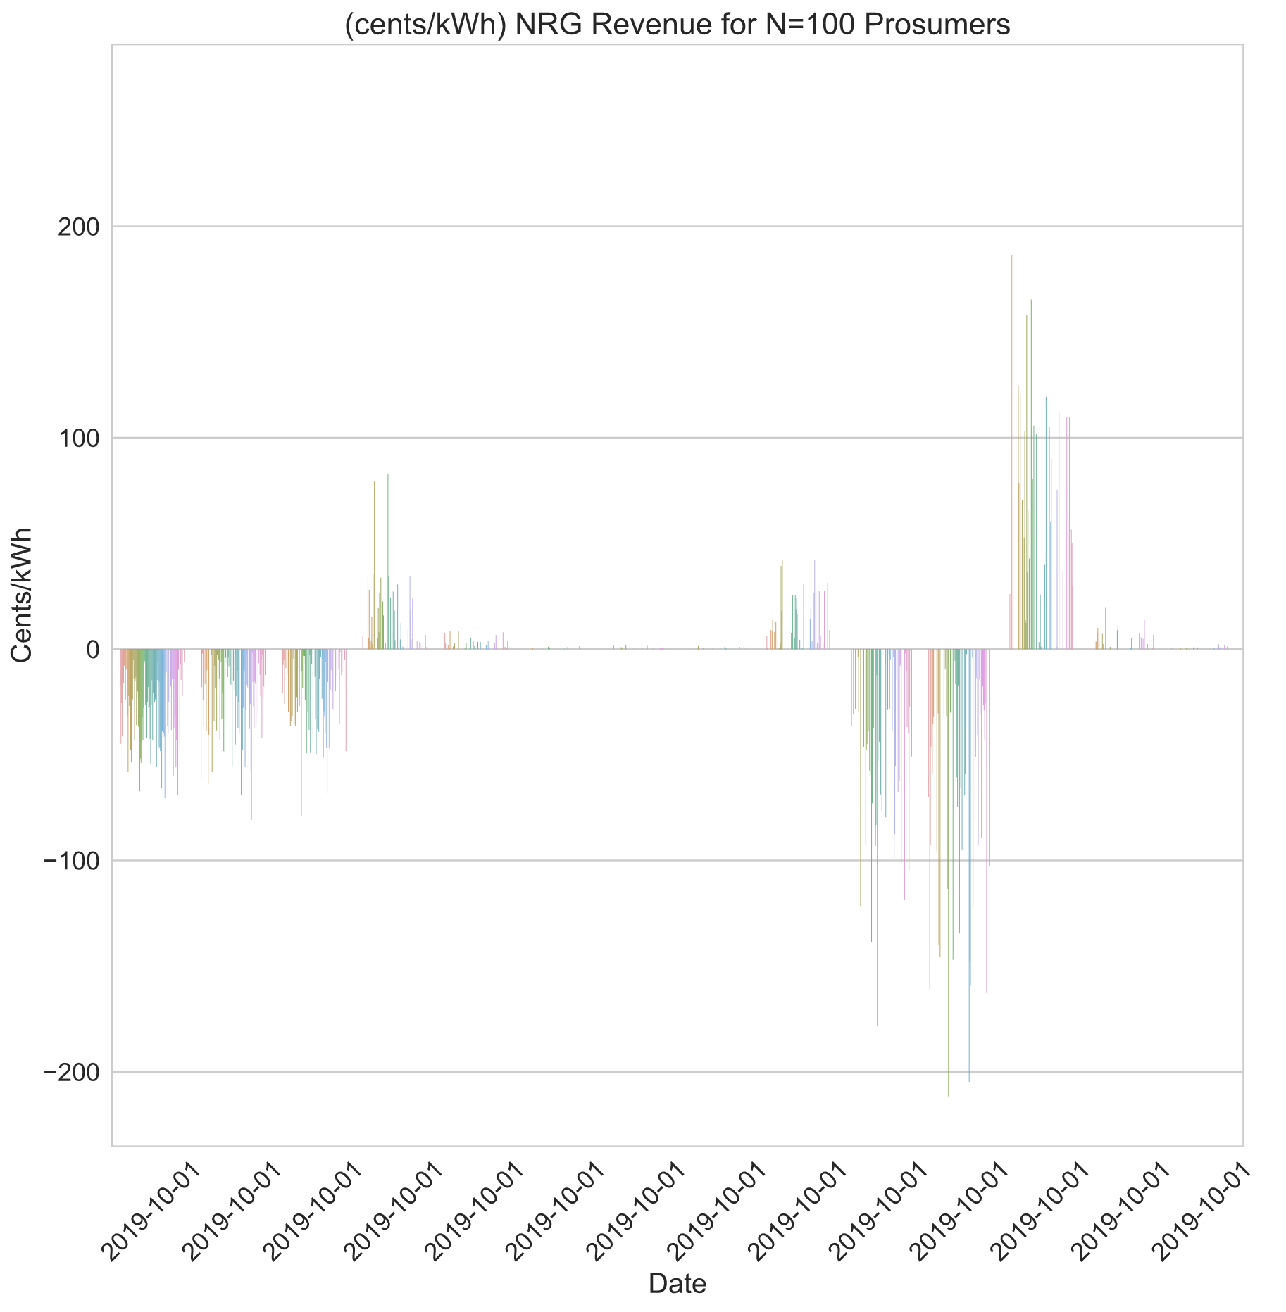

1. Hypothetical generation of Prosumers in a network of N=100 using NRG-X-Change mechanisim for the FPL synthesized data; start of January to end of February, 2020.

# Conclusions

The paper covered an overview of P2P networks and the types of P2P networks. A breakdown of the physical, virtual, and executive layers of a P2P market was covered. A proposal for a novel P2P meter leveraging existing AMI meter form factor was described so that future implementations could avoid costly permits and modifications to existing infrastructure. A prosumer with a PV generation source was used to model a typical prosumer and prosumer network­. The implementation of a P2P prosumer market was designed to be managed by a community manager. The design of an application that can leverage scalable cloud services and monitoring tools using opensource software was described. Core methods describing the use of real-time payment scheme derived from NRG-X-change was reviewed. Finally, a simulation leveraging synthesized data from EIA.gov and NREL shows the results of revenue for prosumers based on networks of N=3 and N=100. The variance in these prosumer networks was statistically modeled to cover variances in home size, performance, and other losses. It turns out that with just PV and variances in performance larger networks are less likely to provide significant revenue for individual prosumers.

# References

|  |  |
| --- | --- |
| [1] | C. (. A. R. Board), "CARB (California Air Resources Board)," 2021. [Online]. Available: https://ww2.arb.ca.gov/homepage. [Accessed 2021]. |
| [2] | C.-C. D. Trancik JE, "Energy Technologies Evaluated Against Climate Targets using a Cost and Carbon Trade-off Curve," *Environ Sci Technology,* vol. 47, 2013. |
| [3] | M. J. T. J. Kavlak G, "Evaluating the causes of cost reduction in photovoltaic modules," *Energy Policy,* vol. 123, no. 700e10, 2018. |
| [4] | B. C. M. J. G. J. R. M. Breyer C, "A top-down analysis: determining photovoltaics R&D investments from patent analysis and R&D headcount," *Energy Policy,* vol. 62, no. 1570e80, 2013. |
| [5] | R. S. S. A. Comello S, "The road ahead for solar PV power," *Renew Sustain Energy,* vol. 92, no. 744e56, 2018. |
| [6] | S. B. Parag Y, "Electricity Market design for the prosumer era," *Nature Energy,* vol. 1(4), no. 1e6, 2016. |
| [7] | d. G. P. A. J. Hashemipour N, "Dynamic allocation of peer-to-peer clusters in virtual local electricity markets: a markeplace for ev flexibility," *Energy,* vol. 236, no. 121428, 2021. |
| [8] | I. D. K. S. Da Silva PG, "The impact of smart grid prosumer grouping on forecasting accuracy and its benefits for local electricity market trading," *IEEE Transactions on Smart Grid,* vol. 5(1), no. 402e10, 2013. |
| [9] | T. K. S. C. Y. T. M. M. D. M. H. V. P. K. L. W. W. Tushar, "A motivational game-theoretic approach for peer-to-peer energy trading in smart grid," *Applied Energy,* vol. 243, pp. 10-20, June 2019. |
| [10] | S. I. S. C. Neves D, "Peer-to-peer energy trading potential: an assesment for the residential sector under different technology and tariff availabilities," *energy,* vol. 205, no. 118023, 2020. |
| [11] | M. L. A. G. Klein LP, "A pragmatic approach towards end-user engagement in the context of peer-to-peer energy sharing," *Energy,* vol. 205, no. 118002, 2020. |
| [12] | H. S. B. M.-I. Mehdi Mehdinejad, "Decentralized blockchain-based peer-to-peer energy-backed token trading for active prosumers," *Energy,* vol. 122713, no. 0360-5442, 2021. |
| [13] | U. S., "Blockchain beyond bitcoin," *Commun ACM,* vol. 59(11), no. 15e7, 2016. |
| [14] | D. A. R. R. J. R. Khorasany M, "Lightweight blockchain framework for location aware peer-to-peer energy trading," *Int J Electr Power Energy Syst ,* vol. 127, no. 106610, 2021. |
| [15] | J. G. K. R. S. K. L. O. a. C. W. E. Mengelkamp, "Designing microgrid energy markets - A case study: The Brooklyn Microgrid," *Applied Energy,* vol. 210, pp. 870-880, 2018. |
| [16] | B. L. W. E. L.-S. W. Soto EA, "Peer-to-peer energy trading:a review of the literature," *Applied Energy ,* no. 116268, 2020. |
| [17] | Z. C. P. J. Y. Z. Han D, " Smart contract architecture for decentralized energy trading and management based on blockchains," *Energy,* vol. 199, no. 117417, 2020. |
| [18] | M. A. R. S. J. ,. S. V. L. R. M. L. a. Z. ,. M. Olson, "Market design and motivated human trading behavior in electricity markets," in *Proceedings of the 32nd Annual Hawaii International Conference on System Sciences*, Hawaii, 1999. |
| [19] | K. R. B. M. P. a. P. O. Kok, "Dynamic Pricing by Scalable Energy Management Systems - Field Experiences and Simulation Results using PowerMatcher," *IEEE Power and Energy Society General Meeting,* pp. 1-8, 2012. |
| [20] | R. R. Siddharth Patel, "Peer to Peer Sharing of Distributed Energy Resources," *arXiv:1808.07839 [cs.CE],* 2018. |
| [21] | J. S. ,. V. M. K. ,. A. N. ,. N. A. Mihaylov Mihail, "NRG-X-change a novel mechanism for trading of renewable energy in smart grids," in *Proceedings of the 3rd International Conference on Smart Grids and Green IT Systems*, 2014. |
| [22] | U. E. I. Administration, "eia.gov," October 2008. [Online]. Available: www.eia.gov. [Accessed 1 11 2021]. |
| [23] | D. E. Krasko V., "Strategic Sequencing for State Distributed PV Policies: A Quantitative Analysis of Policy Impacts and Interactions.," National Renewable Energy Laboratory, Golden, Colorado, 2012. |
| [24] | F.-E.-S. Roberto Verzola, Crossing Over: The Energy Transition to Renewable Electricity, Manila Office: Friedrich-Ebert-Stiftung, 2015. |
| [25] | J. Cummings, "SIRE: Database of State Incentives for Renewables and Efficiency (Website Review)," *Reference Reviews,* vol. 23, no. 10.1108/09504120910969131. , pp. 44-45, 2009. |
| [26] | K. P. L. S. O. M.-S. Steve Pociask, "The Unintended Consequences of Net Metering," American Consumer Institute, a nonprofit educational and research organization, Washington, DC, 2019. |
| [27] | U. E. I. Administration, "Florida State Energy Profile," US Energy Information Administration, 18 11 2021. [Online]. Available: https://www.eia.gov/state/print.php?sid=FL#34. [Accessed 11 12 2021]. |
| [28] | F. P. S. Commission, "Find Your Utility," Florida Public Service Commission, 2021. [Online]. Available: http://www.psc.state.fl.us/ConsumerAssistance/FindYourUtility. [Accessed 11 12 2021]. |
| [29] | I. EnergySage, "How does Florida Power and Light net metering work?," EnergySage, Inc., 2009. [Online]. Available: https://www.energysage.com/local-data/net-metering/fpl/. [Accessed 11 12 2021]. |
| [30] | H.-C. L. V. D. A. I. Uribe-Perez Noelia, "State of the Art and Trends Review of Smart Metering in Electricity Grids," *Applied Sciences,* vol. 6, no. 10.3390, pp. 68-92, 2016. |
| [31] | C. Y. H. M.-R. T. S. H. V. P. ,. K. L. W. W. Tushar, "Transforming Energy Networks Via Peer-to-Peer Energy Trading: The potential of game-theoretic approaches," *IEEE Signal Processing Magazine,* vol. 35, no. 4, pp. 90-111, July 2020. |
| [32] | N. F. S. J. D. M. D. M. T. Morstyn, "Using peer-to-peer energy-trading platforms to incentivize prosumers to form federated power plants," *Nature Energy,* vol. 3, no. 2, pp. 94-101, 2018. |
| [33] | Q. A. J. Ni, "Economic power transaction using coalitional game strategy in micro-grids," *IET Generation, Transmision Distribution,* vol. 10, no. 1, pp. 10-18, 2016. |
| [34] | X. Y. W. F. C. H. T. R. Q. C. a. J. Z. N. Liu, "Online energy sharing for nano grid clusters: A Lyapunov optimization approach," *IEEE Transactions on Smart Grid,* vol. 9, no. 5, p. 46244636, 2018. |
| [35] | V. D. M. A. Sakineh Khalili, "Impact of Blockchain Technology on Electric Power Grids - A case study in LO3 Energy," *ConnectSmart Research Laboratory,* vol. University of Tenesee at Chattanooga, 2020. |
| [36] | Enerchain, "Enerchain® proof of concept," Enerchain, 2019. [Online]. Available: https://enerchain.ponton.de/. [Accessed 2021]. |
| [37] | Sonnen, "Sonnen," Sonnen, 2019. [Online]. Available: https://sonnengroup.com/sonnencommunity/. [Accessed 2021]. |
| [38] | S. Vottem, "Application of Cooperative Game Theory in Smart Grids," in *Texas State University*, San Marcos, Texas., 2019. |
| [39] | E. K. M. O. P. ,. G. C. M. Bender, "Open-Source MQTT Evaluation," in *2021 IEEE 18th Annual Consumer Communications & Networking Conference (CCNC)*, 2021. |
| [40] | D. P. Luo Y., "Autonomous Cooperative Energy Trading Between Prosumers for Microgrid Systems.," in *3rd IEEE International Workshop on Global Trends in Smart Cities go SMART*, 2014. |
| [41] | J. Hamari, M. Sjöklint and A. Ukkonen, "The Sharing Economy: Why People Participate in Collaborative Consumption," *Journal of the Association for Information Science and Technology,* vol. 67, no. 9, pp. 2047-2059, 2016. |
| [42] | S. L. a. H. C. L. W. Park, "A sustainable home energy prosumer chain methodology with energy tags over the blockchain," *MDPI Sustainability,* vol. 10, no. 3, pp. 658:1-658:18, 2018. |
| [43] | A. Z. R. M. Thomas Bennett, "Photovoltaic Model and Converter Topology Considerations for MPPT Purposes," *Solar Energy,* vol. 86, no. 7, pp. 2029-2040, 2012. |
| [44] | C. B. H. L. Kenneth Hansen, "Status and perspectives on 100% renewable energy systems," *Energy,* vol. 175, no. 0360-5442, pp. 471-480, 2019. |
| [45] | S. Nakamoto, "Bitcoin: A Peer-To-Peer Eletronic Cash System," https://bitcoin.org/bitcoin.pdf, 2008. |
| [46] | S. LLC, "Market Research on FPL," Sunshot U.S. Department of Energy, 2020. |
| [47] | S. M. o. A. History, "The Public Utility Regulatory Policies Act," 1978. [Online]. Available: http://americanhistory.si.edu/powering/past/history4.htm. [Accessed 11 12 2021]. |

**Declaration of interests**  
   
☐ The authors declare that they have no known competing financial interests or personal relationships that could have appeared to influence the work reported in this paper.  
   
☒ The authors declare the following financial interests/personal relationships which may be considered as potential competing interests:

|  |
| --- |
| Hector Lopez reports a relationship with NextEra Energy Inc that includes: employment. |